Tyler Young
1 August 2005
Neumont University

Using the ORM2 tool

Using the ORM2 tool 1
Introduction 2
Create a new ORM2 file 2
Entity Types 3
Create an Entity Type 3
Add a Reference Mode 3
Set the Reference Mode’s Data Type 4
Fact Types 4
Create a Fact Type 4
Add a Reading 5
Internal Constraints 5
Add an Internal Uniqueness Constraint 5
Fixing a Role Sequence 6
External Constraints 7
Single-Column External Constraints 7
Multi-Column External Constraints 8
Exploring On Your Own 8

Introduction
Welcome to the new ORM tool!
We still don’t have an actual name for the tool, so anybody who’s reading this document is welcome to post a message to the ORM discussion board hosted by NU and share their thoughts.

In this document, we’ll take a step-by-step approach to creating a very basic diagram, which will hopefully give you the courage to dive in and start using the tool on your own. That way you can find and give us feedback on all the bugs that we haven’t uncovered yet! ☺

At this point, it is assumed that you have VS 2005 Beta 2, the DSL tools framework, VSIP tools and our PLIX tool, and that you have downloaded the code, and successfully built the project. Go ahead and press F5 to build and run it, and let’s get started

Create a new ORM2 file
Welcome to the tool!

Press Ctrl+N to open a new file.
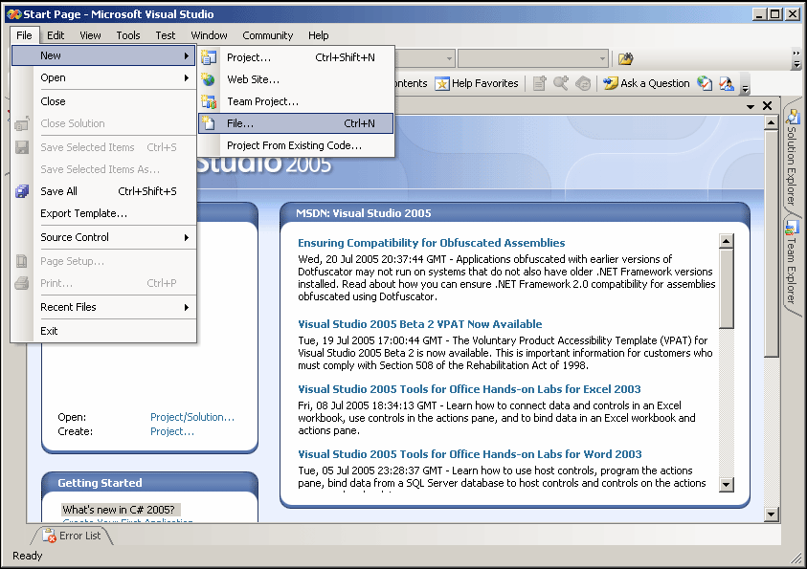

Select ORM Model File
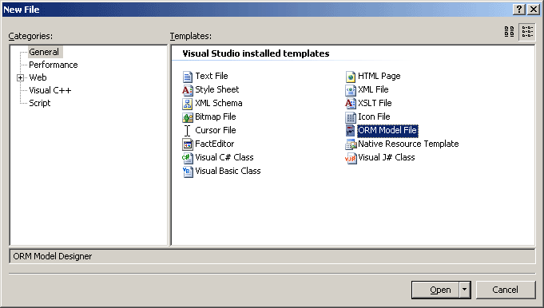

Entity Types

Create an Entity Type
You’ll now have a blank drawing surface to work with. Press “Ctrl+W”, then “X” to bring up the Toolbox. Or you can go to View > Toolbox. During this tutorial, I’ll be including some commonly used keyboard shortcuts that we’ve found useful.
We’ve been trying to put in several ways to access common properties. You’ll find that double-clicking will put you directly into edit mode for some things, right-clicking will let you select some other things to edit, and some things you’ll just have to go to the Properties window for.

UI gestures are something that we’ve put a lot of thought into, because the success of any tool depends heavily on how usable it is. Hammers wouldn’t be nearly so popular if you had to do a standing back flip every time you wanted to hit a nail. We’ve tried to make the tool usable, even in pre-Alpha release, but we realize that what we find to be simple and straight-forward can seem completely obtuse to others. We welcome feedback on the UI gesture set! Let us know what you like and what you don’t, and we’ll hold dozens of meetings about it where donuts will be in ample supply.
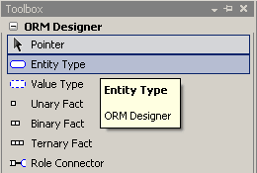

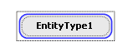
Click once on “Entity Type”, then click once on the diagram surface to place your first Entity Type.


Double-click on the name “EntityType1” to begin editing the default name.

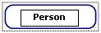
Let’s rename it to something more personable, like “Person”. Type in Person now.

Add a Reference Mode
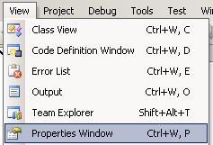
We want to add a reference mode for Person, so let’s go to the Properties of Person. Either navigate from View > Properties Window, or press Ctrl+W, P

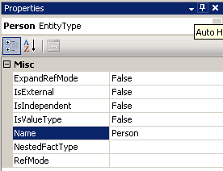
Here you’ll find all sorts of properties that you can change, one of which is Name. We changed that one already, but here’s another place you can change it.

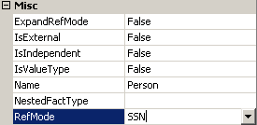
Select the RefMode box, and type in “SSN”.

Set the Reference Mode’s Data Type
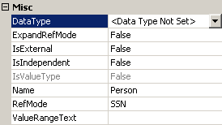
After you press “Enter” (or click off somewhere else), a new box appears in the Properties Window for “Data Type”.

The Data Type is not set for this Reference Mode. Go ahead and click the drop-down arrow and select a data type. I set mine to fixed text.

Bring another Entity Type on to the diagram (you can just click-and-drag “Entity Type” from the Toolbox to the design surface). Rename it to “Car”, and give it a Reference Mode called “VIN” with a Data Type of your choosing

Fact Types

Create a Fact Type
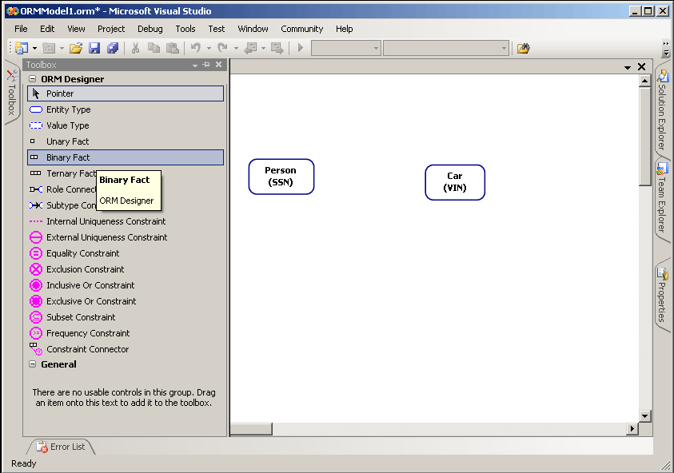
Now we want to bring out a Fact Type to connect the two Entities. After all, this is fact-based modeling! Click on “Binary Fact” in the Toolbox, then click on some empty space between Person and Car.

Connect the Roles
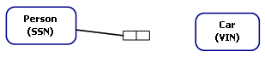
Here’s another UI gesture that you can use to speed things up: After you’ve put your fact type on the design surface, put your mouse in the middle of the left role box. Click and drag from the role box over to the Person entity.
We can hear you complaining already!!

Yes, we know that you want to put your fact types in directly by using text. It turns out that implementing an input language in a nice editor is considerably more difficult than point-and-click graphical gestures.

Don’t worry, we’re hard at work getting a nice text-based input system—just give us a few months.

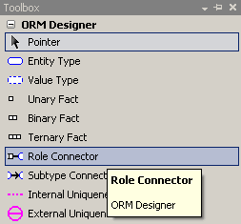
The alternative is to click on “Role Connector” in the Toolbox.

Click on the right-hand role box of our fact, then click on the Car entity. The Role Connector is there for people who don’t know the shortcuts, but we like the first way.

Add a Reading
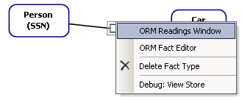
Now we need to add a reading to the fact. Right-click on the fact and select “ORM Readings Window”.
Once you’ve pulled up the readings window, you can dock it and leave it running while you work.

Drag the Reading Editor window around the screen to experiment with docking it.

When a Fact Type is selected on the design surface, the window will show you information about its readings. Otherwise, it just gives you the message, “Select an item related to a Fact Type”.

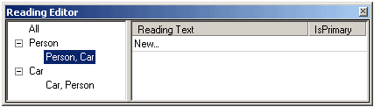
Select the “Person, Car” reading under Person, then click on “New…” under the Reading Text column. Don’t type just yet! It takes a moment for the window to give you the interface.

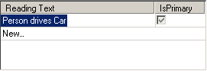
Click to put your cursor between the {0} and the {1} and begin typing. {0} represents the first entity, in this case, Person. {1} is the second, Car. Type in “ drives “ (including spaces before and after “drives”), and press <Enter>.
Notice the “IsPrimary” column. You can have multiple readings for each combination of Entity Types in a Fact Type! Careful though—the tool currently displays ALL the readings at once.

One day when you want to explore things a bit, set up a ternary or quaternary (right-click on a role in a Fact Type and insert a new role to the side of it!) and see how many readings you can put in. Wow!

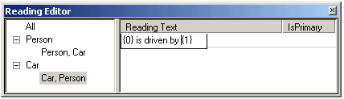
Select “Car, Person” in the left-hand area, and enter the reverse reading.

Internal Constraints

Add an Internal Uniqueness Constraint
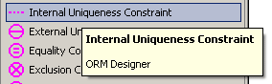
Time to add constraints! Grab an “Internal Uniqueness Constraint” from the Toolbox by clicking on it.

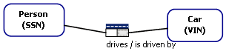
Then click on the fact type.

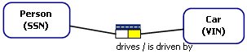
It’s automatically in edit mode, so just click on the right-hand role box to select it.

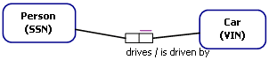
Now double-click on the selected role to commit.

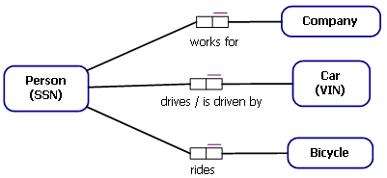
Simple! Now practice your new skills by entering the rest of this model.

Fixing a Role Sequence
If you were a good follower of directions, you entered the model incorrectly, just like me! Upon further validation with the domain expert, we discovered that a Person can work for only one Company, and a Company can have more than one Person that works for that Company.

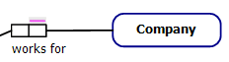
Let’s fix that error by double-clicking on the internal uniqueness constraint. That puts us in edit mode.

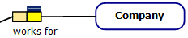
Click on the left-hand role to select it.

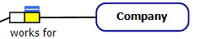
Now hold in the Control key and click on the right-hand role to deselect it.

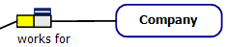
Finally, double-click on the left-hand role (Actually you can double-click on any yellow, selected role) to commit the constraint’s role sequence.
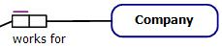
Now we’ve fixed the incorrect constraint. Whew!

External Constraints

Single-Column External Constraints
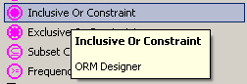
Now that we have a more fully populated (and more correct) model, let’s add some external constraints. Start with an “Inclusive Or Constraint” from the Toolbox.

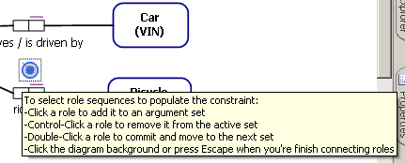
Place it on the diagram between “Person drives Car” and “Person rides Bicycle”. In this universe you can’t simply walk to work, and there’s no car pooling allowed!

Click on the Person roles in both of these facts.
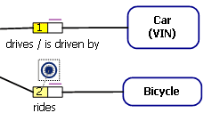

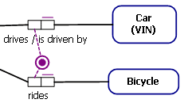
Then double-click either of these roles to commit the new role sequence.

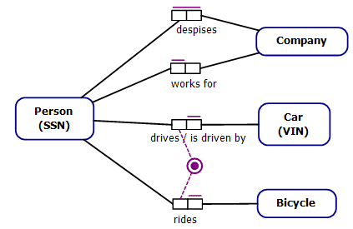
Let’s get a bit more fancy. Expand the model to allow a person to despise many companies, and for a company to be despised by many people.

Multi-Column External Constraints
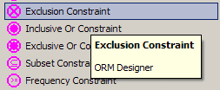
Grab an Exclusion Constraint from the Toolbar

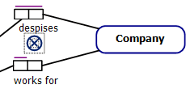
Click between “Person despises Company” and “Person works for Company” to set the constraint down.
For this universe, a person cannot work for a company that they despise. Really, this should be a deontic constraint instead of alethic.

When we implement deontic constraints, I’ll be sure to update this tutorial to show you how to do them!

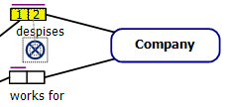
As usual, once you put the Constraint Type down you’re automatically in edit mode. Click on Person’s role for the “despises” fact, then on Company’s role.

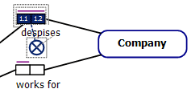

Double-click on either of those roles to commit the role sequence.

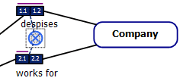
But what’s this? We’re STILL in edit mode!! That’s because Exclusion constraints accept more than one sequence of roles. We (creatively) call them “Multi-Column External Constraints” to differentiate them from external constraints like Inclusive Or that only take one sequence of roles. Those are called “Single-Column External Constraints”.

Click on Person’s role in “works for”, then on Company’s role.

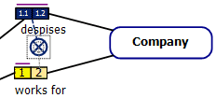
Double-click on a selected role to commit it, and behold the beautiful model you’ve created!

Exploring On Your Own
So there you have it! You’ve created a new ORM2 diagram, populated it with entities and with fact types, added readings, and you’ve even put some basic external constraints on your diagram. There’s still more for you to explore, though. Keep the Properties window handy and click on various things on the diagram to see what it lets you change. You’ll be able to turn Entity Types into Value Types, add names to roles, and even objectify Fact Types.

Questions about this tutorial may be posted in the ORM2 discussion group hosted by Neumont University or directed to the author, Tyler Young (tyler.young@student.northface.edu).

